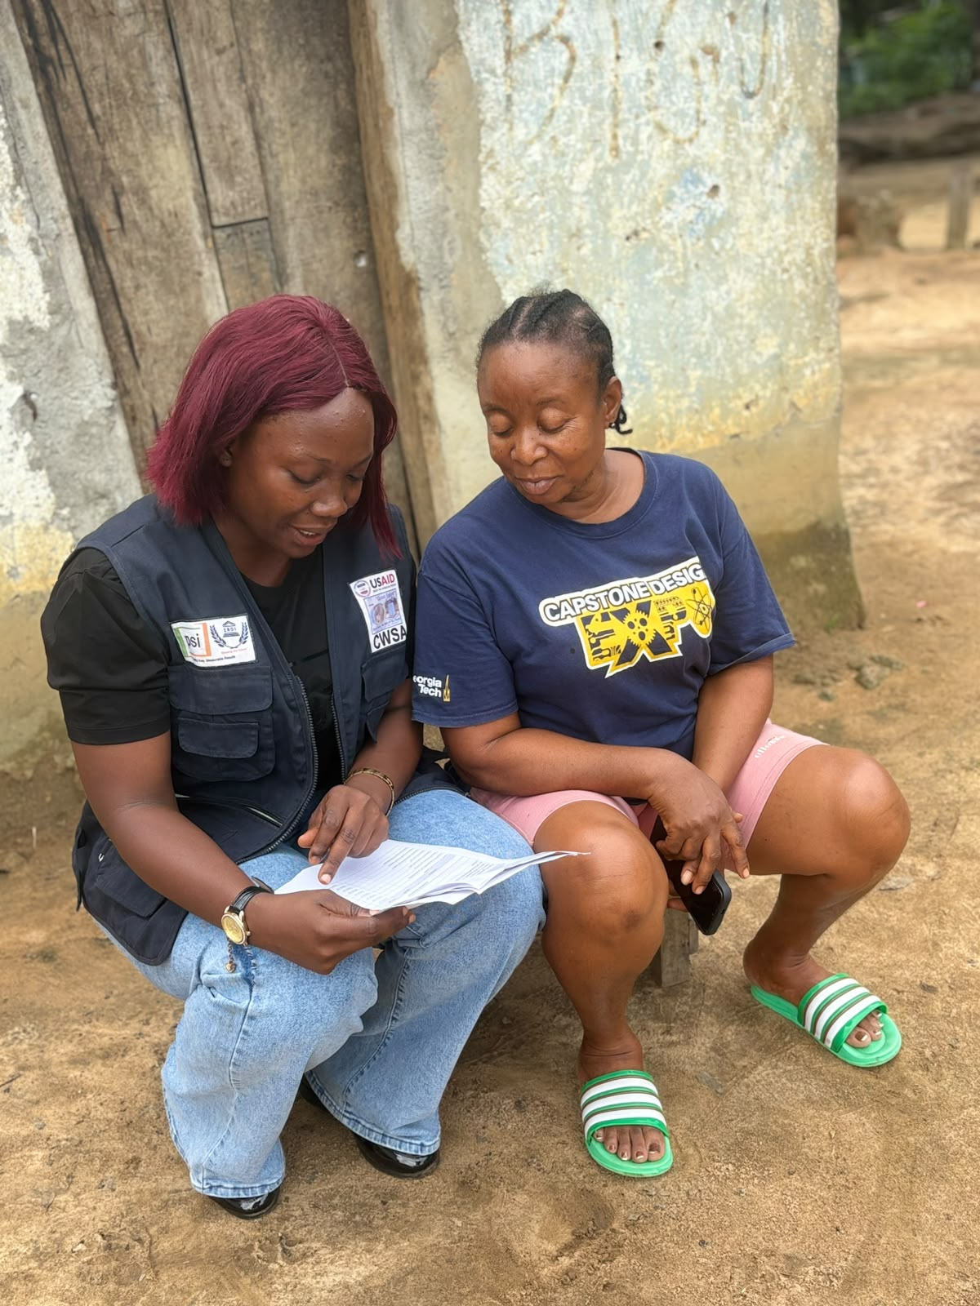
ERDI Conducts Health Facility Mapping exercise in Bong and Nimba Counties

Efficient research and Development Institute (ERDI) conducted a baseline survey on health facility mapping in Bong and Nimba Counties. The exercise is intended to mapped health facility and health service deliver structures in Communities. The exercise was sponsored by ERDI’s British partner All We Can, under the project called walking together in Partnership.

