ERDI Constructs 400meters road to link future home in Ganta
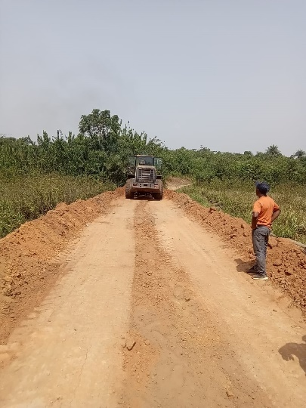

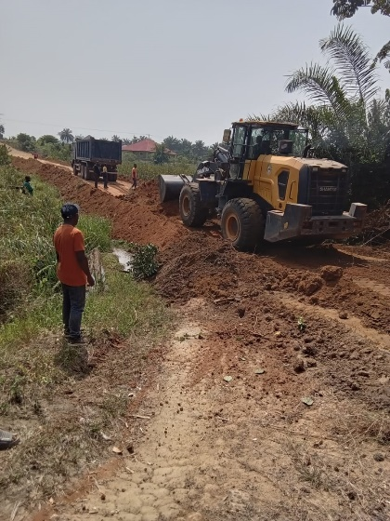
Efficient Research and Development Institute (ERDI) and partners have constructs 400 meters road to link her future home in Ganta City. The road constructed is a major boost to the Community as it stands as major street (Avenue) for farmers and Community dwellers.

